A New Defendant at the Table:
An Overview of Missouri School Finance and Recent Litigation

Michael Podgursky, Professor of Economics, University of Missouri – Columbia

James Smith, President, Management Analysis and Planning

Matthew G. Springer, Research Assistant Professor of Public Policy and Education, Peabody College of Vanderbilt University

October 18, 2007

Prepared for the “From Equity to Adequacy to Choice” Conference. Truman School of Public Affairs / Missouri Show-Me Institute, October 30, 2007. The usual disclaimers apply.

Abstract

Like many other states, Missouri has gone through several rounds of school finance litigation. However, the trial just concluded was unusual in two respects. First, three taxpayers were allowed to intervene for the defense and, in the process, raise important questions concerning the efficiency of school spending and broader questions of school reform. Second, the outcome at the circuit court level, which focused nearly entirely on points of law, was a complete victory for the defense. This essay provides an overview of disputes of Missouri school finance and evidence pertaining to some of the points in dispute at the trial. These lessons generalize to other states facing school finance litigation. The authors conclude that changes in school funding formulas, and the seemingly interminable litigation about those formulas, are not an effective vehicle for addressing achievement gaps or the overall level of school performance.
I. Introduction

On October 17, 2007 a Missouri Circuit Court handed down a major decision upholding the constitutionality of the current Missouri school finance system. However, this is but one milestone in a long road of litigation stretching back more than a decade. In this regard Missouri is hardly unusual. Many other states have experienced prolonged litigation surrounding school finance. What made the Missouri case unusual – indeed, unique –was the fact that a group of three taxpayers intervened for the defense. This not only raised the overall vigor and quality of the defense, it also provided a vehicle for raising questions about efficiency with which schools use their current funds, and opened the door, at least a crack, for testimony about market-based school reforms and value-added measures as alternative remedies to the complaints of the plaintiffs.
The plaintiffs in the Missouri case are three groups of school districts, 264 in all, representing roughly 60 percent of Missouri public school enrollments. Each group of districts has a bill of grievances against the current school finance regime. The nominal defendants are various state officials and the state Board of Education, but in practice, the real defendant was the state legislature, which crafted the school finance law.
This paper provides a survey of some of the key issues of education finance considered in this case. We begin with a general background on school finance litigation nationally. This is followed by some specifics of the Missouri case, including the historic intervention by taxpayer defendants. We then consider evidence in three key areas: the overall level and trend in K-12 resources in Missouri, ways of measuring the fairness (equity) in the distribution of these resources, and finally, the relationship between these education resources and student achievement. We close with some observations on the efficacy of using school funding formulas to address student achievement gaps.

II. Background

National Litigation in School Finance

Equity and adequacy are perhaps the two most prominent principles in school finance policy. Broadly speaking, school finance equity refers to fairness in the distribution of educational goods and services. Adequacy is less well defined. However, to proponents it usually refers to the availability of a sufficient level of resources for all students to reach some level of performance. Often the latter is defined in reference to performance on state assessments (e.g., “proficient”), although some courts have talked about more nebulous goals. For example, the Kentucky Supreme Court in Rose v. Council for Better Education laid out seven capacities that must be the goal for every child under a constitutionally "efficient" system of education: (i) sufficient oral and written communication skills to enable students to function in a complex and rapidly changing civilization; (ii) sufficient knowledge of economic, social, and political systems to enable the student to make informed choices; (iii) sufficient understanding of governmental processes to enable the student to understand the issues that affect his or her community, state, and nation; (iv) sufficient self-knowledge and knowledge of his or her mental and physical wellness; (v) sufficient grounding in the arts to enable each student to appreciate his or her cultural and historical heritage; (vi) sufficient training or preparation for advanced training in either academic or vocational fields so as to enable each child to choose and pursue life work intelligently; and (vii) sufficient levels of academic or vocational skills to enable public school students to compete favorably with their counterparts in surrounding states, in academics or in the job market.
School finance litigation has gone through three broad phases, shifting from a focus on the distribution of educational resources to attempts to establish a relationship among education inputs, processes, and outcomes (Guthrie, Springer, Rolle, and Houck, 2007). The first phase ran from the late 1960s until 1973, and was adjudicated under the U.S. Constitution’s equal protection clause. The second phase began with the U.S. Supreme Court’s 5-4 decision in San Antonio Independent School District v. Rodriguez (1973), which concluded, in part, that education is not a “fundamental right” under the U.S. Constitution’s equal protection clause. As a consequence, and for nearly two decades, school finance litigation relied on state constitutions’ equal protection education clauses to guide legal challenges against state funding structures. The third phase of school finance litigation started when the Kentucky Supreme Court declared the state’s entire system of public and elementary and secondary education unconstitutional, and held that all Kentucky schoolchildren had a constitutional right to an adequate educational opportunity (Rose v. Council for Better Education, 1989).
The number of legal challenges against school funding mechanisms is quite substantial. More than 125 court cases challenging the constitutionality of school district and school spending levels have been filed since the late-1960s, an average of slightly more than three cases per year (Guthrie and Springer, 2007). Of these challenges, 12 states have had their state funding mechanism ruled unconstitutional on equity grounds and 23 states have had their state funding mechanism ruled unconstitutional on adequacy grounds. Only five states – Delaware, Hawaii, Mississippi, Nevada, and Utah – have not had their state school funding mechanisms adjudicated in the courts.
The cumulative impact of school finance litigation on school spending is considerable. In a recent state-by-state measure of the long-term fiscal impact of court mandated school finance reform, Atkins (2007) estimates that lawmakers have authorized an additional $34 billion in annual spending or taxes to comply with court mandated reform since 1977. While the author notes that the majority of these states (18) either have spent surplus funds or cut spending in other program areas to meet court directives, 9 states have raised taxes by a total of almost $13 billion per annum. Atkins’ estimates do not take into consideration the tens of millions of dollars incurred by taxpayers in school finance litigation.
The Missouri case is unusual in that, unlike any other such cases, a substantial portion of the defense were borne by private citizens. Litigation is expensive. It is difficult to determine total costs of litigation in school finance cases because in most instances parties are not required to report this information. Sunshine Act requests have established that the plaintiff districts in the Missouri have spent roughly $3.2 million since 2004 on this case--and this does not count the litigation costs for the defense. When the Wyoming legislature was facing its fourth round of litigation in Campbell County v. Wyoming, it finally required the plaintiff school districts to report all litigation-related expenses. They reported spending $2,886,122 on the fourth trial alone. The state’s counsel estimates that his agency spent about half that amount on the same trial. Likewise, in a recent South Carolina case, plaintiffs’ attorneys reported fees and costs of approximately $6 million, and defense attorneys estimated fees and costs of approximately $3.5 million. In both instances the amounts reported include only monetary expenses, but not the opportunity cost of the time and effort used by school district and state agency personnel in responding to requests for information, being deposed, testifying, etc.
School finance litigation has also shaped state school funding mechanisms. In 1998, for example, Murray, Evans, and Schwab (1998) concluded that as a result of court-mandated reform intrastate inequality was dampened to the point that disparities between states were greater than disparities within states. The authors also concluded that spending rose in the lowest and median spending school districts and remained constant in the highest spending school districts. A more recent study by Springer, Liu, and Guthrie (2007), however, examined whether differences in resource allocation patterns exist between equity- versus adequacy-based reform. They found that both equity- and adequacy-based school finance reform resulted in changes in a state’s funding mechanism. However, the authors did not detect any differences between court-mandated equity- versus adequacy-based reform, nor did they discover any evidence of adequacy-based reform resulting in the allocation of additional resources to low wealth districts when compared to outcomes under court-mandated equity reform. Berry (2007) undertook a similar examination, making some statistical corrections for serial correlation and find generally very weak effects of either type of litigation on a range of fiscal variables.
Missouri Litigation
Missouri’s school finance system was challenged on equity grounds and found unconstitutional in 1993. The legislature responded by passing the School Improvement Act of 1993, which called for an extensive overhaul of the school funding mechanism by means of an increase in elementary and secondary education spending and decoupling local tax collections from local wealth. The legislature put in place a financing formula meant to reduce the link between district wealth per student and district school revenues. In theory, if a property-rich and a property-poor district had the same tax rate the state would make up the difference and equalize revenues. If a school district exerted the appropriate tax effort, it was guaranteed the tax revenues of a school district at the 95th percentile of property wealth. Thus, a school district with one-quarter the wealth of a 95th percentile district would get three dollars of state aid for every one dollar of local revenue.
This was an ambitious goal and the state legislature was never able to fully meet this revenue target. While real spending per student rose briskly in the years following this reform (Figure 2), the legislature slipped further behind in meeting the SB 380 spending target. A recession in 2001 led to cuts in almost all areas of state spending except K-12 education. However, while real spending on K-12 education rose, it did not rise fast enough to meet this funding target. The problem is that full funding under this formula required that state spending track property values in the wealthiest (95th percentile) districts. While state income rose over this period, it did not keep up with the rise in housing prices, particularly in the wealthiest districts (Podgursky and Springer, 2006).
Restive school districts threatened another lawsuit if the SB380 formula was not “fully funded.” In 2004, in preparation for an “adequacy” lawsuit, the Missouri School Boards Association contracted with a consulting firm (Augenblick and Meyers) to conduct an “adequacy” study of Missouri school spending. These consultants approached this question in two ways. The first, a “professional judgement” approach, was to put together panels of educators and administrators to ask what level of spending would be required to meet student achievement goals in a school. The second, sometimes labeled the “successful schools” approach, was to examine the spending levels of school districts that met Department of Elementary and Secondary Education (DESE) performance targets. Both approaches found large spending shortfalls. Augenblick and Myers reconciled the recommendations of the two approaches and concluded that in 2001-02 Missouri was under-spending by $913 million, not including cost of transportation, food services or capital expenditures. Myers testified at trial that even at increased spending in SB287, Missouri was under-spending by $800 million.
In response to these concerns, and in an attempt to forestall the adequacy lawsuit, the legislature adopted a “successful schools” approach in the new funding scheme. The latter approach formed the basis for the new spending scheme adopted by the legislature in 2005. The legislature took as their target guaranteeing that every school district in the state would have revenues at least that of 113 school districts designated “distinguished” in the 2003-04 academic year by DESE. The “distinguished” designation was computed on the basis of the level or gains in student achievement. The new law, SB 287, represented an overhaul of the state funding formula.
In 2005, the legislature determined that the minimum adequate level of spending was $6,117 dollars per student. The legislature arrived at this figure by calculating the average operating spending per student for the 113 districts with perfect or nearly perfect scores on the Annual Performance Report (APR) conducted by DESE. APR scores are heavily weighted toward performance on the MAP assessment. This figure will be recomputed every two years. In theory, the figure could go down, however SB287 specifies that the old level will stay in effect should that occur.
While the legislature had hoped to forestall an “adequacy” lawsuit by adopting a successful schools approach, a group of plaintiffs districts choose to proceed with litigation. The original lawsuit, originally filed in 2004, was reactivated and went to trial in January – March of 2007.
A New Defendant at the Table
Until this point the Missouri case resembled dozens previously filed in many other states. On the plaintiff side was a core group of 236 heavily rural or small town districts (Committee for Educational Equality). These districts typically, although not consistently, had below average spending per student. They were joined by two other interveners on the plaintiff’s side. The first was the Coalition to Fund Excellent Schools (CFES), a group of 28 wealthy suburban school districts. The second was the St. Louis school district.
The plaintiffs and interveners thus included the wealthiest and poorest school districts in the state, with a broad group in between. What explains this odd collection? In fact, this type of strategy is not uncommon in school finance cases. The wealthy CFES districts, in particular, wanted to make sure that whatever the court might decide would not come at their expense. In a case such as this, one might easily imagine remedies that would redistribute state aid from wealthier districts to the poorer ones. Intervening as co-plaintiffs was a way for the wealthy districts to steer the case away from such threatening territory. The St. Louis district’s participation was motivated by its unique struggles--indeed, since the trial it has lost accreditation and has effectively been placed in receivership by the state. As one of the highest spending districts in the state, their goal was to avoid any remedy that might come at their expense.
The named defendants in this case included the state legislature, DESE and various other government officials. In practice, the defendant was the state legislature, since it was the architect of the school finance system in dispute. As in all other such cases, it is the duty of the Attorney General (AG) and his staff to defend the state. Thus, in the courtroom the “defense” team are lawyers and staff from the AG’s office and the plaintiffs are lawyers and staff from law firms representing the three plaintiff groups.
What is unusual, and in fact historic, about this case is that three taxpayers intervened as defendants. In the period leading up to the trial there was concern in some quarters that the AG, a Democrat with clear gubernatorial ambitions (the Governor is Republican), was not preparing an adequate defense. In a petition to the court, the three taxpayer interveners (Rex Sinquefield, Menlo Smith, and Bevis Schock) claimed that the defense was doing an “incompetent” job. There was a good deal of evidence that the defense was poorly prepared as the trial approached. While the court rejected their claim of incompetence, they did admit them as defendants. We are aware of no other school finance case in the country where this has happened.
The presence of these interveners changed the dynamic of the case. Financed entirely by private donations, they hired an aggressive and experienced trial lawyer. They also brought in several experts from around the country with extensive school finance trial experience. More importantly, they acted independently to raise questions concerning school efficiency and remedies such as school choice, that were not part of the AG’s defense. Thus, the judge heard a much wider range of opinions and options than would have otherwise been the case.
III. Selected Points of Contention
As is common practice in adequacy cases, the plaintiffs confronted the court with a barrage of concerns and complaints. This tactic may arise because a very diverse group of plaintiff districts (who are paying legal fees) want their particular grievances aired, or merely a hope on the plaintiff’s part that some complaint out of the potpourri will resonate with the judge.
In this case the list of complaints was replete with issues and charges about nearly every conceivable aspect of school funding in Missouri. Of course, the leitmotif of the case was that the state did not provide school districts enough money, but also, the claim that the Missouri school finance formula resulted in inequitable funding among school districts occasioned multiple expert reports and considerable testimony from several witnesses. We will describe this issue in more detail later, but first, we will consider the list of other complaints raised by Plaintiffs. These complaints are most interesting primarily because of their breadth and diversity. They will be described approximately in the order they were addressed in Plaintiffs’ “Finding of Facts” submitted to the Court at the conclusion of the trial.
Plaintiffs’ global charge was that the state “violated the Missouri Constitution through disparities, inadequacies and inequalities of the school funding formula…new, increased and expanded requirements have been funded in violation of the Hancock Amendment to the Missouri Constitution… [and] the funding for these requirements has been shifted to…districts and to the taxpayers.”
The plaintiffs argued that the new funding formula either failed to provide funding for students identified as gifted, or failed to provide sufficient funding for such students. They charged that the state did not provide funding for transportation, employee background checks, compliance with federal Individuals with Disabilities Act, or homeless student services. They further complained that the state did not adequately fund the costs of state mandated graduation requirements, student assessments, or early childhood education programs. They argued that the seven year phase-in of the new school finance formula was unconstitutional, that the state did not provide adequate funding to build and maintain facilities, and that the regional cost adjustment (Dollar Value Modifier) failed to compensate for the higher costs of urban districts. Several witnesses testified that the weights the legislature used to calculate the costs for special needs students (LEP, economically disadvantaged, and special education) were inadequate.
The Level and Distribution of District Spending Per Student
Assessment of the plaintiffs’ “adequacy” claims must begin with the Missouri constitution. As in many other states, the Missouri constitution provides for free public schools. Section 1(a) of the constitution states:
A general diffusion of knowledge and intelligence being essential to the preservation of rights and liberties of the people, the general assembly shall establish and maintain free public schools in this state within ages not excess of twenty-one years as prescribed by law.

There is no further description of what a free public education entails, although one unique feature of the Missouri Constitution is that section 3(b) establishes a minimum percentage of public revenues to be dedicated to public elementary and secondary education.

In event the public school fund provided and set apart by law for the support of free pubic schools, shall be insufficient to sustain free schools at least eight months in every year in each school district of the state, the general assembly may provide for such a deficiency; but in no case shall there be set apart less than twenty five percent of the state revenue, exclusive of interest and sinking fund, to be applied annually to the support of free public schools.

In his decision, Judge Callahan notes that the requirement is unique to the Missouri Constitution.

This first hurdle is readily met. Figure 1 shows the percent of state revenues devoted to free public schools under various definitions of education spending and state revenues computed by a University of Missouri Economist, Joseph Haslag, and presented at trial. Under every reasonable measure (and there are alternative ways of measuring both the numerator and denominator), state spending on education far exceeds the 25 percent threshold.
(Figure 1)
Whatever K-12 spending may be as a percent of state revenues, it is useful to know how spending per student figure stacks up against other states and the nation. Figure 2 shows that Missouri ranks somewhat below the middle (32) in current spending per student. In this and some subsequent figures we report not only Missouri but the seven surrounding states. In part this reflects the generally lower wage structure in the mid-west as compared to some other states. Our surrounding states are all in the lower two-thirds of the distribution of states, with Missouri in the middle of this group as well. There is no simple way to adjust the data for “cost of living” since a statistically reliable cross-section cost of living index does not exist. However, the National Center for Education Statistics has developed a Current Wage Index (CWI). The CWI is an index that is based on the level of earnings for college-educated workers in the labor market area. As such it can be used to compare education labor earnings to those of other college-educated workers. According to the CWI, the general wage structure in Missouri is about 10 percent below the national average. Since labor costs account for the lion’s share of per-student education costs, if we take the CWI as an accurate measure of education labor costs, then a ten percent upward adjustment in current spending per student would entirely close the gap between Missouri and the U.S. average.
(Figure 2)
While Missouri spending per student is below the national average, over the past decade or more it has been consistently rising in real terms, and at a somewhat higher rate than the national average. Figure 3 reports the average inflation-adjusted spending in Missouri and the US since the 1989-90 school year. Real per student spending nationally rose at a 1.6 percent annual rate whereas the annualized rate for Missouri was 1.9 percent.
(Figure 3)
At issue in this case is how equally these resources are distributed among school districts. Before discussing making any types of interstate comparisons of spending inequality it is important to understand something of the landscape of school districts in Missouri. Relatively speaking, Missouri has a lot of school districts--75 K-8 and 447 K-12, 522 regular school districts in all—many of which are quite small. In many of our comparisons, we will focus on surrounding Midwestern states. Most of these states also have a large number of school districts, many of which are rural. Second, Missouri has a highly skewed distribution of students among these districts: Some have very few students and some have many. Table 1 reports the distribution of students by decile of district size, from lowest to highest. The smallest 10 percent of Missouri districts enroll just 0.5 percent of all students. The smallest 20 percent of districts (i.e., 104 of 524) enroll just 1.5 percent of public school students. By contrast, the largest 10 percent enroll over half (57 percent) of the students. In fact, the largest ten school districts enroll just over 25 percent of the students, and the five largest enroll 16 percent.
(Table 1)
As discussed above, most of the early wave of school finance cases focused on how equitably resources were available to school districts. For most of the history of public schooling in America, local school districts primarily were funded by local property taxes. This arrangement produced often dramatic differences among districts in the amount of resources available for educating students. Beginning in California with Serrano v. Priest (1971), state courts around the nation decided that such funding disparities were unconstitutional and that the amount of funding available to an individual student should be dependent on the wealth of the state as a whole, and not on whether a student was lucky enough to live in a district wealthy in assessable property. In 1993 Missouri’s school finance system was declared unconstitutional because of such funding disparities among school districts.
These early cases addressed what is commonly termed horizontal equity, i.e. the extent to which all students have access to substantially the same level of resources. (Berne and Stiefel, 1983). Identical spending per pupil in every district would yield perfect horizontal equity. Such a funding formula, at least tacitly, assumes that every child’s education requires identical resources to produce. Most experts in school finance now recognize that some students have characteristics that may require that greater resources be applied to their education. This concept is commonly known as vertical equity, i.e. the amount of resources made available is dependent upon an individual student, or group of students’ identified educational needs. Perfect vertical equity requires that spending be based solely on student need.
Horizontal equity is a straight forward, relatively easily measured concept. Vertical equity may conceptually be straight forward, but in practice it defies precise measurement primarily because the technology of education is not well understood. The state-of-the-art does not allow one to reliably predict the effects of any intervention, input or combination of inputs.
Complexity is further exacerbated by the imprecise methods of identifying and classifying students with additional needs. Most high-needs classifications tend to be subjective and cover an often broad range of student characteristics. Take for example, two 12 year old students from Mexico, one has attended school in rural Mexico for only the equivalent of four years, the second transferred from an elite private school in Mexico City. The former barely reads in Spanish. The latter has studied English for six years. Both probably would be identified as limited English proficient (LEP), and in most states would generate identical amounts of extra funding. Should either or both be placed in a bilingual class, language immersion class, ESL class, or none of the above? There is no definitive science to guide educators in these choices, and each choice carries implications for the required level of spending. Identification and treatment for special education, gifted, economically disadvantaged, etc. suffer from similar imprecision.
In the quest for vertical equity, state school finance systems sometimes take into account other factors that may affect costs faced by school districts regardless of the characteristics of their students. Small districts may face diseconomies of scale that increase per pupil costs. Other districts may be located in areas where the costs of goods and services require them to offer higher salaries to attract and retain qualified staff. Others may, because of demographic trends, employ teachers with more than average experience that, under current pay schemes, receive higher than average salaries.
Perfect horizontal equity and perfect vertical equity are mutually exclusive. States that choose, at least in part, to condition the level of revenues per pupil a school district receives on the likely needs of its students or other cost factors will fare poorly on measures of horizontal equity. This trade-off is illustrated in Figure 4.
(Figure 4)
Missouri compensates districts for several cost differences, and as a consequence, tilts in the direction of vertical equity. The current formula adds compensatory funding for districts whose student populations exceed specified thresholds of students eligible for federally subsidized meals (FRL), students identified as limited English speaking (LEP), or handicapped. The previous formula similarly provided extra funding to districts with concentrations of students with greater educational needs. The effect of these policies can be seen in Figures 5-7.
Figure 5 plots weighted measures of school spending inequality for Missouri and seven surrounding states. Several patterns emerge. First, inequality for Missouri is considerably higher than all of the surrounding states. Second, inequality dropped sharply in the wake of the 1993 court decision, but the decline stopped by the late 1990’s. Thus, by a measure of horizontal equity Missouri compares poorly with surrounding states.
What about vertical equity? Here the story changes. Figure 6 shows the correlation between per-pupil spending and student poverty in MO and surrounding states for 1990 to 2002, the latest period for which there is available data. Figure 7 displays the correlation between per-pupil spending and percent minority students in MO and surrounding states. These graphs clearly demonstrate that MO spends significantly more on students who are more likely to have greater than average needs. This is a consequence of deliberate policy choices to attempt to compensate districts that likely face higher than average costs because of the characteristics of students attending their schools. Most states and the federal government provide some form of compensatory funding, but as can be seen from Figures 6 and 7, Missouri has one of the more aggressive policy structures in this regard in the region. To most observers this would be a good thing, but Plaintiffs expert witnesses Richard Salmon and Lisa Driscoll concluded that MO school finance was inequitable and generally getting worse.
(Figures 5-7)

“Adequacy” in Relation to Student Test Scores
A critical claim of plaintiff in the Missouri and other adequacy cases is that there is a constitutional standard of adequate spending defined relation to a certain set of student skills. In other words, in order to make sure that students have a certain set of academic skills, it is necessary to spend at least X dollars per student (where X can be adjusted based on student need). This, in turn, assumes that there is a statistically reliable and causal positive relationship between school spending and student achievement. Let us consider each of these in turn. By “statistically reliable,” we mean that the relationship is stable because the student achievement associated with a given level of spending is highly predictable. To put it simply, an expenditure level of $8,000 per student would be consistently associated with a given level of student achievement, and an expenditure level of $10,000 per student would be associated with a higher, predictable level of achievement. In the world of NCLB, this reliability is taken to mean “if I spend X per student I can expect to see a proficiency rate of A, and if I spend 1.25 X I can expect to see a proficiency rate of B, where B is bigger than A.”
The second condition is equally important. Even if we found a positive and stable statistical relationship between district spending and student achievement, it does not mean that the latter caused the former. For example, it may be that high-spending districts are also districts with more affluent, well-educated parents. It is well-established in the research literature that the most powerful predictors of student achievement are family background factors, particularly parents’ education (Hoxby, 2001). While school-age children spend roughly 1100 hours per year at school, they spend thousands of hours more at home. Moreover, parental nurturing during the pre-school years also plays a very important role in children’s development (Armor, 2003). Many studies have demonstrated that the “summer melt” is much larger for children from low- as compared to high-SES families. (Cooper, et.al., 1996). The bottom line is that, on average, higher income families make larger human capital investments in their children at home. If high-income families cluster in high-spending school districts this will produce a positive relationship between spending per student and student achievement even if school spending has no causal effect on student achievement.
In the court case, one of the authors made an exhaustive examination of student level data on the state-wide Missouri Assessment Program, the state assessment used in public schools. We will not report all of those results, but will focus on just a few charts. The “remedies” in school finance trials focus on changes in how the states fund school districts, and “equity” and “adequacy” are defined in terms of school districts, not students. The presumption is that interdistrict gaps in student achievement are a major source of student achievement gaps. In fact, the data in Figure 8 show that interdistrict gaps in student achievement are a minor source of achievement inequality for students and the vast majority of inequality in achievement is within school districts. Here we report what are called ANOVA decompositions. Basically each bar represents total student achievement inequality (100%) for each test (communications arts, math) at each grade level (3-8, high school). Total inequality of achievement at any grade can be broken into the sum of two components: inequality between districts and inequality within the districts. The share of variation between districts is the percentage of inequality that would disappear if all school districts had the same average test score. As both charts show, the vast majority of inequality is within rather than between districts. At most only 15-20 percent of math inequality and 10-15 percent of communication arts inequality is between districts. The overwhelming share of inequality is within districts. Thus even if equalizing spending across districts eliminated all interdistrict inequality of spending, the vast majority of inequality would remain. In spite of the fact that the vast majority of inequality is within rather than between districts, it is typical in school finance trials for experts on both sides to focus on average district achievement and average district spending.
(Figure 8)
In light of the minor role played by interdistrict variation in inequality, we believe the proper area of focus is student level achievement data. We have analyzed such data at all grade levels. The interested reader is referred to the full trial report. However, Figures 9 and 10 depict a consistent pattern. Each dot in these diagrams depicts a student (or more commonly, a “stack” of students with identical scores). The first diagram shows 8th grade math scores for all students in the state (roughly 71,000). Along the horizontal axis is displayed the average current spending in the district. If district spending per student had a powerful effect on achievement, one would expect to see a positive relationship between achievement and spending. Instead what one finds is a “cloud” of scores with no apparent relationship. In fact, a regression line fit through these data has a slightly negative slope. Moreover, these data reinforce the finding discussed above, namely that the vast majority of inequality is within rather than between districts. Since every student in a district is assigned the same value of spending per student, these score distributions are stacked district by district, ranked by spending. Not only is there no positive relationship between spending and average achievement, but there is no tendency toward compression either. High-spending districts are just as unequal as low-spending districts.
(Figure 9)
It might be argued that a chart such as this, which plots all students, confounds the effect of student SES and race. It is well known that low-SES students on average have lower test scores. The same is true for African-American students. Thus, if districts with above-average spending per student also have above-average shares of high poverty or African-American students then a positive effect of spending on student achievement by be confounded by this SES or racial effect. In order to neutralize the latter, we plot in Figure 10 identical data just for African American students who are free- and reduced-price lunch eligible (FRL), a standard measure of student poverty (roughly 8400 such students were tested in 8th grade). Once again, there is no evidence of a positive effect of district spending.
(Figure 10)
IV. Conclusion
In this paper we have reviewed some of the evidence presented in the recent school finance trial (CEE II). While many states have experienced such litigation, the Missouri experience was unusual in two respects. First, three taxpayers were allowed to intervene on behalf of the defense. This opened the door to a more vigorous rebuttal by the defense experts and, more importantly, permitted the defendants to raise important questions concerning the efficiency of school spending and school reform. It is a model that should be considered in other states. Second, the trial at the circuit court was a complete victory for the defense. While recent school finance cases have not gone well for the plaintiffs, this one was a particularly sharp loss. We believe the latter followed as a direct consequence of the former--the taxpayer intervention played a strong role in sharpening the defense.
We reviewed some of the key evidence presented to the court concerning equity in the distribution of educational resources and the feasibility of establishing a level of “adequate” resources with reference to student achievement. Like most states, in recent decades Missouri has consistently increased the real spending per student in K-12 education. In fact, real per-student spending has risen faster than the national average. When we consider how equitably those resources were distributed, we showed that there are potentially important differences in how one measures inequality. When considered simply in terms of the inequality of spending per student (horizontal equity), Missouri does not compare favorably to surrounding states. However, in vertical equity measures, which adjust spending for student need, Missouri compares very favorably. Finally, we show that efforts to specify an “adequate” level of K-12 spending per student by reference to student test scores is a hopeless endeavor. It is simply not possible to identify a statistically reliable relationship between district spending and student achievement.
In closing, we believe the data shows that school finance litigation is much too blunt an instrument to address issues of student achievement gaps. There is simply no evidence that court-induced changes in school finance play an important role in changing student achievement gaps. Unfortunately, the remedies being suggested to the courts – changing formulas for state aid to school districts – have virtually no relationship to student achievement gaps since the vast majority of student achievement inequality is within rather than between districts. If school finance systems are to be challenged in courts, we believe that the student should be the focus of judicial remedies rather than “school districts.” True equity and efficiency is more likely to be achieved with state dollars are attached to students, whose resources travel with them as their parents choose the best school to fit their needs.

Table 1
Enrollment by District Size: 2004-05
Percentile  Of District  Size | % of Students | Cumulative  % of  Students
Deciles
10 | 0.5% | 0.5%
20 | 1.0% | 1.5%
30 | 1.5% | 3.0%
40 | 2.3% | 5.3%
50 | 3.1% | 8.4%
60 | 4.2% | 12.6%
70 | 5.7% | 18.3%
80 | 8.9% | 27.2%
90 | 15.8% | 43.0%
100 | 57.0% | 100.0%
Largest 5 districts | 16.0% | ---
Largest 10 districts | 25.8% | ---

Source: Missouri Department of Elementary and Secondary Education

Figure 2: Current Expenditure Per Student in Missouri and Other States, 2003-04

$0
$2,000
$4,000
$6,000
$8,000
$10,000
$12,000
$14,000
Utah
Arizona
Oklahoma
Idaho
Mississippi
Nevada
Tennessee
Alabama
North Carolina
Florida
Arkansas
Kentucky
South Dakota
Texas
South Carolina
Louisiana
North Dakota
Washington
Colorado
Missouri
New Mexico
Oregon
Iowa
California
Georgia
Kansas
Montana
Virginia
Minnesota
Indiana
Nebraska
Hawaii
West Virginia
Illinois
Ohio
Michigan
New Hampshire
Wisconsin
Wyoming
Maryland
Pennsylvania
Maine
Alaska
Delaware
Massachusetts
Rhode Island
Vermont
Connecticut
New York
District of Columbia
New Jersey
OK
TN
KY
MO
rank = 32
IA
KS
NB
IL

Source: U.S Department of Education, Digest of Education Statistics, 2006

Figure 3

Trends in Inflation-Adjusted Current Spending Per Student, 1989-90 to 2003-04

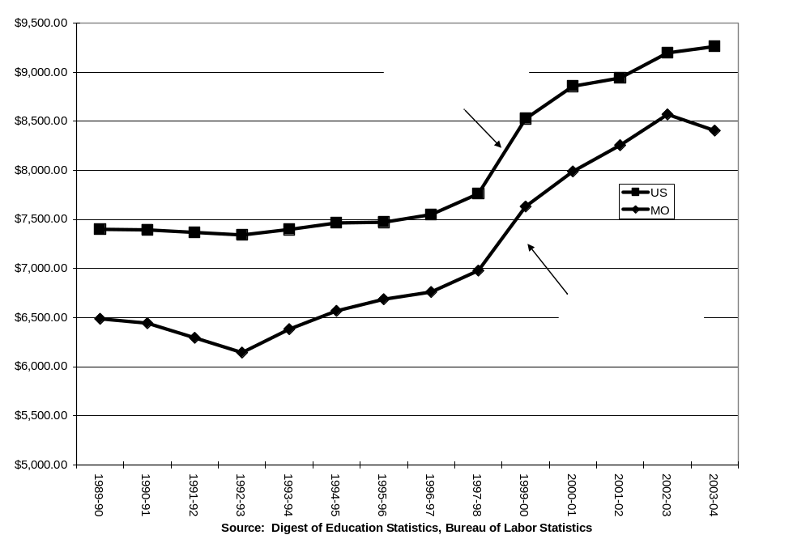

Figure 1

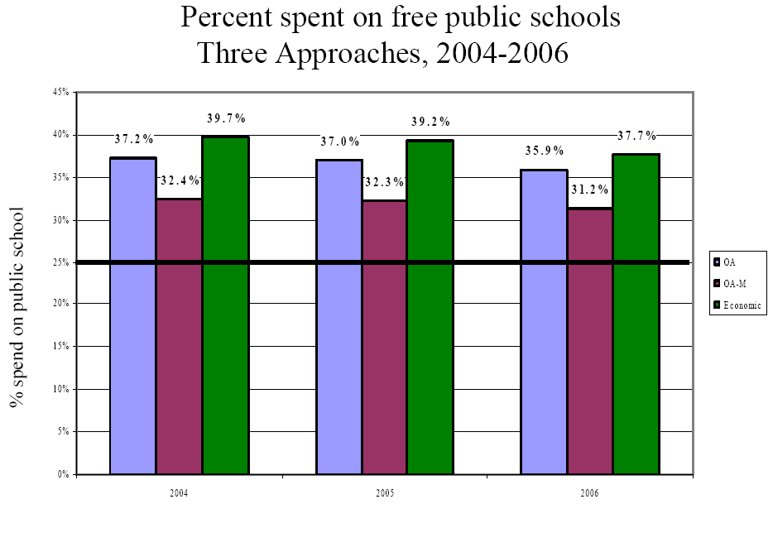

Source: Haslag (2007)

Figure 4

The Trade-Off Between Horizontal and Vertical Equity

Horizontalequity
Vertical Equity
A
B
Which system is “fairest?”
Figure 5
Measured Inequality in Current Spending Per Student in Missouri and Surrounding States:
1972-2002
(Number of Regular School Districts in Parentheses)

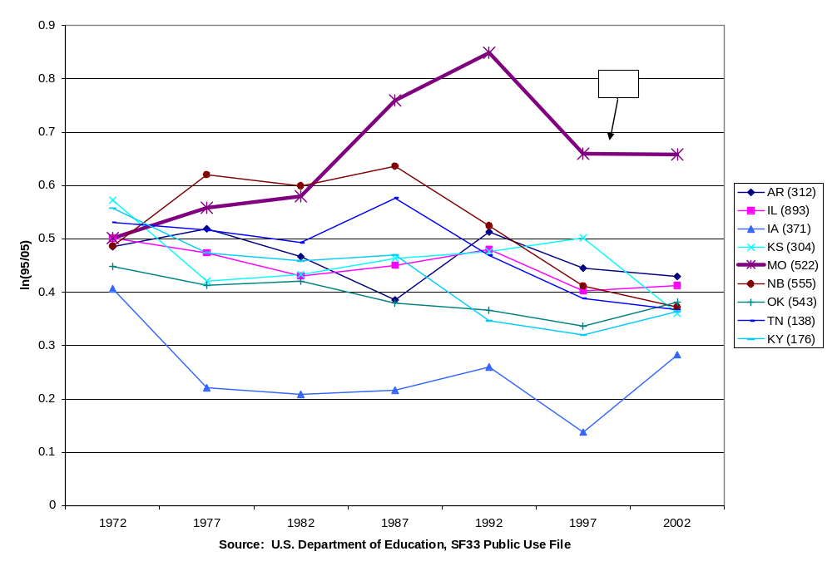

Source: U.S. Census Bureau, Elementary and Secondary School System Finance Data Files (F-33). Inequality measure (ln(95th//5th percentiles) ). Number of school districts (2002) in parenthesis in legend.
Figure 6
Correlation Between Current Spending Per-pupil spending and Student Poverty
in Missouri and Surrounding States:
1990=2000
(Number of Regular School Districts in Parentheses)

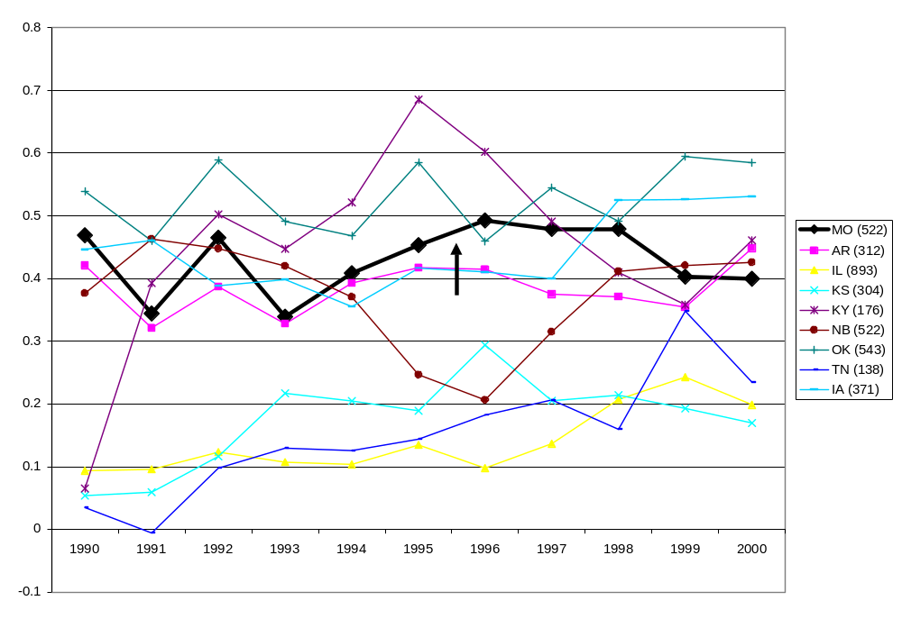

Source: National Center for Education Statistics, Longitudinal School District Fiscal-Nonfiscal Data File. Inequality measure (ln(95th//5th percentiles) ). Number of school districts (2002) in parenthesis in legend.
Figure 7
Correlation Between Current Spending Per-pupil spending and Percent Minority
in Missouri and Surrounding States:
1990=2000
(Number of Regular School Districts in Parentheses)

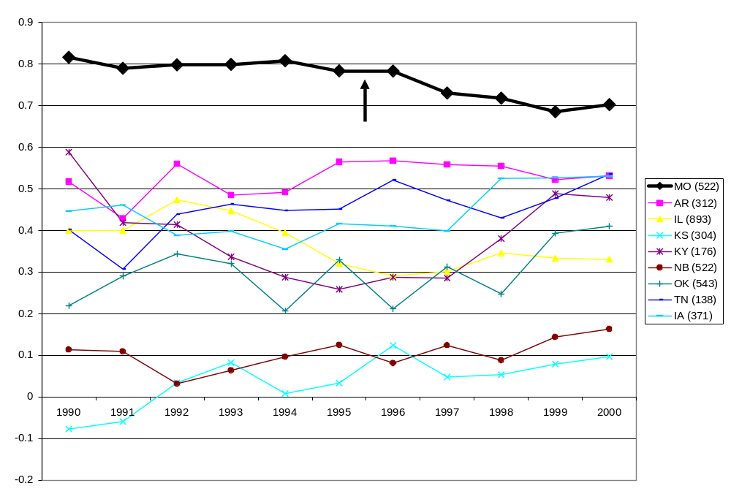
Figure 8: Sources of Variation of 2006 Student MAP Test Scores:
Within and Between Districts by Grade Level

A. Math
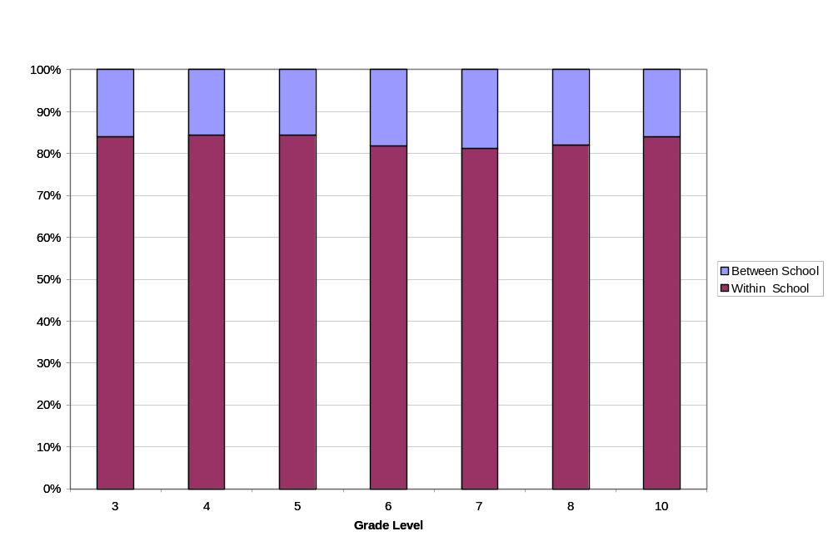

B. Communication Arts
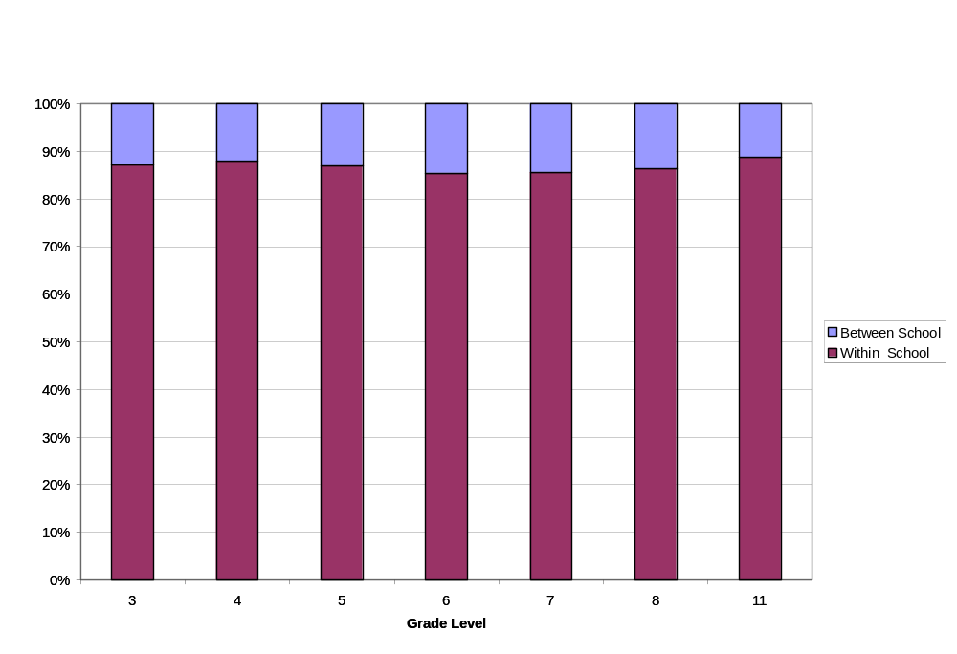
Figure 9

2006 Grade 8 Math MAP Test Scores and Current Expenditures Per Student

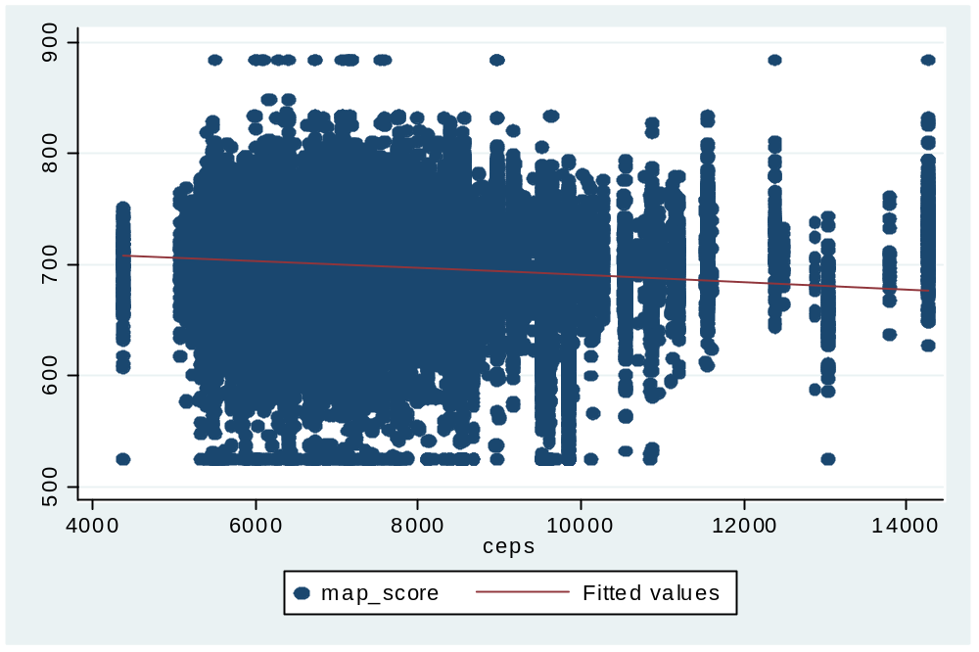

Source: Missouri Department of Elementary and Secondary Education. All reported District MAP scores with at least 25 valid test scores in beginning and ending year.

Figure 10

2006 Grade 8 Math MAP Test Scores and Current Expenditures Per Student:
African-American Students Who Are FRL Eligible

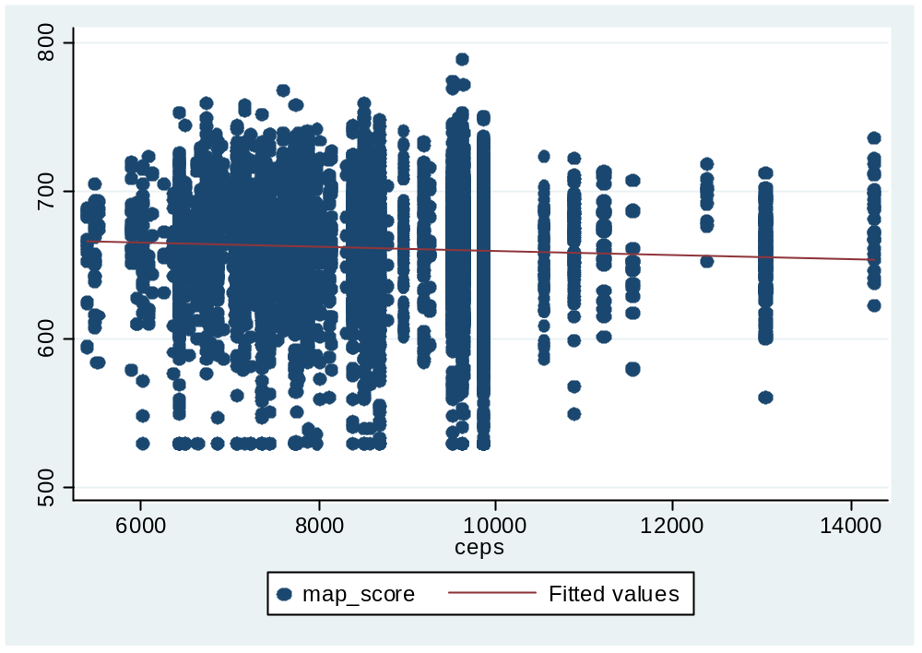

Appendix A
Spending by Plaintiff School Districts on Campaign for Educational Equity v. Missouri to Date

References

Armor, David J. Maximizing Intelligence. 2003. Transaction Publishers, Rutgers University

Atkins, C. (2007). Appropriation by Litigation: Estimating the Cost of Judicial Mandates for
State and Local Education Spending. Washington, DC: Tax Foundation

Augenblick, J. & Myers, J. (2003). Calculation of the Cost of an Adequate Education in Missouri Using the Professional Judgment and the Successful School District Approaches. Missouri Coalition for Adequacy. Downloaded from http://www.msbanet.org/pdf/adequacy.pdf in February 2005.

Berne, R. & Stiefel, L. (1983). The Measurement of Equity in School Finance: Conceptual, Methodological, and Empirical Dimensions. Baltimore, MD: Johns Hopkins University Press.

Berry, C. (2007) “The Impact of School Finance Judgments on State Fiscal Policy.” in M. West and P. Peterson. School Money Trials: The Legal Pursuit of Educational Adequacy. Washington DC: Brookings Institution Press.

Clark, Melissa A. “Education Reform, and Student Achievement: Evidence From the Kentucky Education Reform Act. October 2003. Mathematica Policy Research. Princeton, NJ

Cooper, H., B. Nye, K Carlton, J. Lindsay, S Greathouse. 1996. “The Effects of Summer Vacation on Achievement Test Scores: A Narrative and Meta-Analytic Review.” Review of Education Research. Vol. 66 No. 3 pp. 227-68.

Edgewood School District v. Kirby, (TX), 777 SW2d 391 (1989).

Franck, Matthew. “Taxpayers Pay Tab in School-Funding Lawsuit.” St. Louis Post-Dispatch. Oct. 10, 2007.

Guthrie, J.W., Springer, M.G., Rolle, A.R., and Houck, E.A. (2007). Modern Education Finance
and Policy. Boston, MA: Allyn and Bacon Press.

Guthrie, J.W. and Springer, M.G. (2007). Alchemy: Adequacy Advocates Turn Guesstimates
into Gold. Education Next, 7(1), 20-27.

Hanushek, E.A. (2005). “Pseudo-Science and Sound Basic Education.” Education Next, 5(4), 67-73.

Hanushek, E.A. (2003). The Failure of Input-Based Resource Policies. The Economic Journal. 113(485) (February), F64-F98.

Hanushek, E. A. & Rivkin, S.G. (1997). Understanding the 20th Century Growth in U.S. School
Spending. Journal of Human Resources, 32(1), 35-68.

Haslag, Joseph. (2007). Spending on Free Public Schools: Expert Report
http://www.schoolchoiceformissouri.org/trial/pdf/Haslag%201011%209-18-07%20revised.pdf

Hembree, R. (2004). The Hancock Amendment: Missouri’s Tax Limitation Measure. University of Missouri. Truman School of Public Affairs. Missouri Legislative Academy. Report 49-2004. http://truman.missouri.edu/ipp/mla/documents/49-2004Hancock%20Amendment.pdf

Hoxby, C.M. (2001). All School Finance Equalizations are Not Created Equal. The Quarterly
Journal of Economics, 116(4), 1189-1231.30

Hoxby, Caroline and Ilyana Kuzienko. 2004. “Robin Hood and His Not So Merry Plan: Capitalization and the Self-Destruction of Texas’ School Finance Equalization Plan.”

C Hoxby, C. 2001. “If Families Matter Most, Where do Schools Come In?” in T.M. Moe (ed.) A Primer on America’s Schools. Palo Alto, CA: Stanford, Hoover Institute Press.
Cambridge, MA: NBER. Working Paper 10722 (August).
Hussar, W. & Sonnenberg, W. (2002). Trends in Disparities in School District Level Expenditures Per-Pupil. Washington, DC: National Center for Education Statistics.
Iaterola, P. and Steifel, L. (2003). “Intradistrict Equity and Public Education Resources and Reform.” Economics of Education Review. 22 (1), pp. 60-78.
Kane, T.J., Orszag, P.R. & Gunter, D.L. (2003). State Fiscal Constraints and Higher Education Spending: The Role of Medicaid and the Business Cycle. Washington, DC: Brookings Institution.
Ladd, H.F. & Hansen, J.S. (1999). Making money matter: Financing America’s schools.
Washington, DC: National Academy Press.

Murray, S.E., Evans, W.N., Schwab, R.M. (1998). Education-Finance Reform and the
Distribution of Education Resources. The American Economic Review, 88(4), 789-812.

National Center for Education Statistics (2002). Digest of Education Statistics, 2002. Washington, DC: United States Department of Education.

Roza, M and P. Hill. (2004) “How Within District Spending Inequities Help Some Schools to Fail.” Brookings Papers on Education Policy. Washington, DC: The Brookings Institution, pp. 201-227.

Roza, M., K Guin, B. Grosse, S. Deburgomaster. (2007) “Do Districts Fund Schools Fairly?” Education Next. 7(1) (Fall), pp. 68-74.

Rose v. Council for Better Education, (KY). 790 SW2d 186, 60 Ed. Law Rep. 1289 (1989).

Committee for Educational Equality v. State of Missouri, No. CV190-1371CC, slip op. (1993).

Serrano v. Priest, 5 Cal. 3d. 584, 96 Cal Rptr. 601, 487 P. 2d. 1241 (1971).

Springer, M.G., Liu, K., and Guthrie, J.W. (2007). The Impact of Education Finance Litigation
Reform on Resource Distribution: Is There Anything Special About Adequacy? Nashville, TN: Peabody Center for Education Policy Working Paper.

U.S. Department of Education. National Center for Education Statistics. 2006. A Comparable Wage Approach to Geographic Cost Adjustment. NCES 2006-321 (May).

Taxpayer-funded spending to date totals at least $4.6 million. This includes $3.6 million by the school districts and $1.4 million by the state AGO to a private law firm for assistance in the litigation. (Franck, 2007) These totals do not include the time of the AGO staff.
Abbeville County School District v. State of South Carolina. Correspondence between the authors and State’s Attorney, and counsel for the State Legislature.
It is likely that plaintiffs view expenditures for litigation as cost effective. First, and perhaps foremost, these costs are borne by taxpayers, not the individuals involved. Second, winning almost always results in significant increases in school district revenues. Finally, increases in school district revenues almost always result in pay raises for teachers and administrators. See for example Clark 2003, Hanushek and Rivkin 1997
Committee for Educational Equality v. State of Missouri (1993)
See trial testimony of Robert Costrell for a critique of the methodology Augenblick and Myers employed in their “adequacy” study.
In several states the Attorney General or other state agency contracts with a private law firm to represent the state.
See Interveners’ Motion to Intervene.
Article X, Section 16, of the Missouri Constitution provides in part as follows: The state is prohibited from requiring any new or expanded activities by counties and other political subdivisions without full state financing, or from shifting the tax burden to counties and other political subdivisions. Article X, Section 21, of the Missouri Constitution provides as follows: The state is hereby prohibited from reducing the state financed portion of the costs of any existing activity or service required of counties and other political subdivisions. A new activity or service or an increase in the level of any activity or service beyond that required by existing law shall not be required by the general assembly or any state agency of counties or other political subdivisions, unless a state appropriation is made and disbursed to pay the county or other political subdivision for any increased costs. CEE Findings of Facts.
There is no scientific evidence for any particular funding weight, a point conceded by one of the plaintiff experts. The decision to weight a poor student at 1.2 or 1.4 times a non-poor student reflects a normative decision by legislatures as to fairness in resource allocation, rather than an objective assessment of the “cost” of educating the two types of students.
Officially, Missouri has 524 school districts. However, for this study we drop two, the St. Louis and Pemiscot County Special School Districts, and focus only on regular school districts.
Committee for Educational Equality v. State of Missouri (1993)
Salmon, Richard G, and Lisa G. Driscoll, “An Analysis of Fiscal Equity Provided by the Missouri System for Financing Public Schools: 1992-93 to 2004-05, Expert Report” December 1, 2006
The complete report is available here: http://www.schoolchoiceformissouri.org/trial/trial_selected_defense.html
Stated more formally, ANOVA decomposes total variation in student test scores into two components: variation in mean achievement between districts, and variation within the district around the district mean.
A similar decomposition can be made within and between schools. At least 80 percent of achievement inequality is within schools.
One important limitation of school finance data in Missouri and most other states is that spending per student can only be measured at the district level. Thus all students in the same district are assigned the same value of per-pupil spending rather than a measure of the actual resources expended on them. While spending per student is generally not available a the school building level, some researchers have been able to secure school-level resource data in some districts (Roza, et.al, 2007; Roza and Hill, 2004; Iatarola and Stiefel, 2003 ) They find considerable intra-district inequality, arising primarily from differences in average teacher pay between schools

